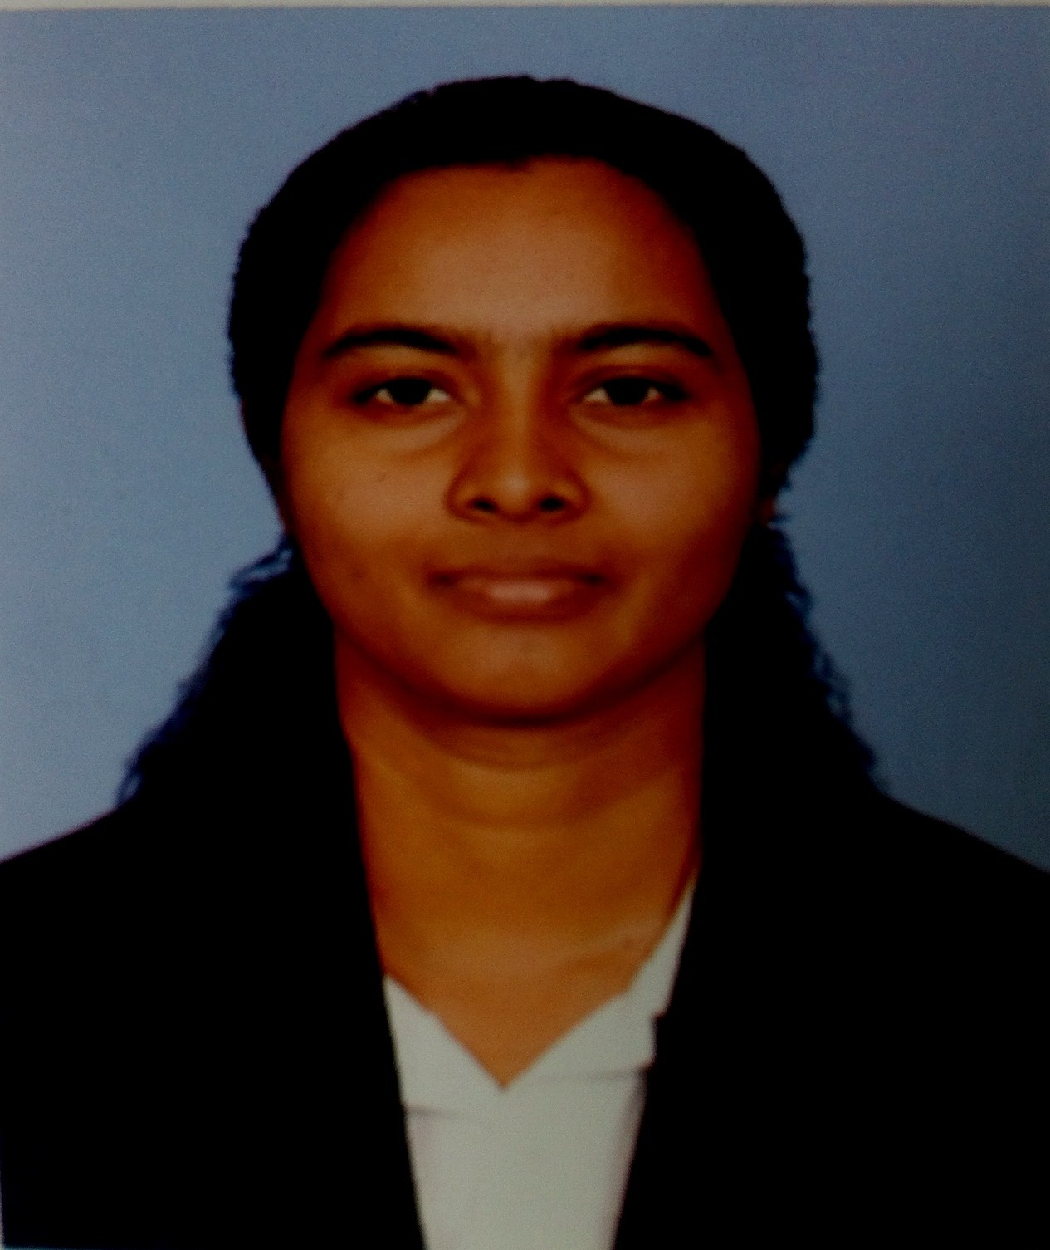
CURRICULUM VITAE
Akurugoda Hewage Buddhi Subhashani

Address : No.275/6, Himbutana Road,Mulleriyawa, New-Town.

Phone : 011-3140664

Mobile : 077-5413046

Email : buddhisdn7@yahoo.com

Career Objective

To obtain a position of responsibilities that utilizes my skills and experience and keen to work an environment where I can achieve organizational goals as well as my own career development.
To obtain a position of responsibilities that utilizes my skills and experience and keen to work an
environment where I can achieve organizational goals as well as my own career development.
To obtain a position of responsibilities that utilizes my skills and experience and keen to work an
environment where I can achieve organizational goals as well as my own career development.

Education

- B.A Degree (External) – University of Kelaniya
Psychology / philosophy / political Science
- Successfully Completed a one year Diploma in Counseling – Faculty of Medical science, University of Sri Jayawardanapura.
- Successfully completed Advance Certificate Course in HRM at National institute of Business Management (NIBM)
- GCE(Advance Level) Examination – 2009 (Arts Stream)
Sinhala –B / Logic and Scientific Method – B / Political Science – C, General English-S
- Passed the G.C.E (Ordinary Level) Examination in 2003
Mathematics – A / Buddhism – A / Sinhala Literature – A / Sinhala – B /
Commerce – B / Dancing –B/Social Studies – C /Geography – C/ English – A
Science – C
- Passed Dhamma School Final Certificate Examination 2004

Professional Experience

Hand on Experienced Two years as a primary Teacher at J.M.C International College.

Technological Proficiencies

- Windows Os
- Microsoft office suite
- Internet Navigation
Certificates

Displayed talents –
- Athletic event at the Inter House Sports Meet in field of Sports
- Obtained victories in Oratory, Dancing, Reading and comprehension Competitions held in School pertaining to Sinhala Language day Days,
- Obtained victories in poem competition held in School pertaining to English Language day Days,
- Certificate for School Attendance.

Personal Details

- Date of Birth : 21st March 1987
- Gender : Female
- Civil Status : Single
- NIC Number : 875810456 V
- Nationality : Sri Lankan (Sinhalese)
- School Attended : - Janadhipathi Balika Vidyalaya, Nawala
- Rathnawali Balika Vidyalaya, Colombo

Extra Curricular Activities

- Secretary of The Organization of “help”
- President of Science Society
- Member of School :
  - Athletic Team
  - English Literature Society
- Participated in the -
- National essay competition held by department of Buddhist affairs.
- Displayed talents in field of Sports –

  - Athletic event at the Inter House Sports Meet Regional and Zonal Meets
  - Volley ball, Net Ball and badminton

Other Qualifications

- I have successfully completed a Special Speech Training in English at the Department of Official Language

Referees

H.Somalatha (Mrs)
Nursing Officer
National Institute of Mental Health – Angoda
T.P.0774586202

R.P.N.Rajapaksha(Mrs)
Nursing officer
National Hospital – Colombo
T.P.0712830693

I hereby declare that the above information furnished by me is true and correct to the best of my knowledge.
15/02/2016 Buddhi Subhashani
Date Signature

